1) Write a JavaScript function called text_to_array that prompts the user to enter some phrase, and after that, each word in the phrase is stored in an array called words. Each slot of the array contains one word. (Do not worry about punctuation.) Hint: use the split method to split the text by " "

<!DOCTYPE html>

<html lang="en">

<head>

<meta charset="UTF-8">

<meta name="viewport" content="width=device-width, initial-scale=1.0">

<title>Q1.Text_To_Array</title>

<script>

function text_to_array() {

try {

inp = prompt('Enter some phrase, let me split it and store in an array')

if (inp.length == 0) {

throw "Enter something..don't leave it empty";

}

words = inp.split(" ")

var i = 0;

for (i; i < words.length; i++) {

document.write('Slot:' + i + ' Element:' + words[i] + '<br/>');

}

document.write(words)

} catch (error) {

document.write('<h1>Error:</h1>' + error)

}

}

text_to_array()

</script>

</head>

<body>

</body>

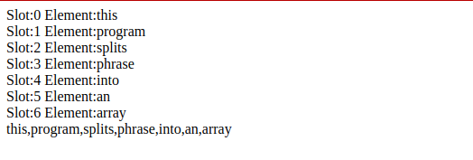</html>

2) Write a JavaScript function called reverse_sort that takes as an argument the array words and sorts it in reverse lexicographical order.

<!DOCTYPE html>

<html>

<head>

<title>Q2.Reverse_Sort</title>

</head>

<body>

<script type="text/javascript">

var words=prompt("Enter an array of space separated words to sort it in reverse chronological order");

reverse_sort(words);

function reverse_sort(words)

{

try{

if(words==" ")

{

throw e;

}

else

{

word=words.split(' ');

document.write("Reverse array is: "+word.sort().reverse()+"<br>");

}

}

catch(e)

{

document.write("Enter a valid paragraph");

}

}

</script>

</body>

</html>

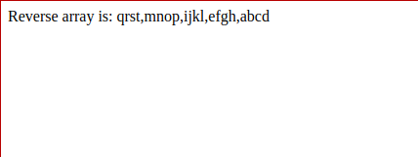

3) The user is prompted to enter numbers until he hits cancel. Then, a histogram

of these numbers is printed to the browser. For example, if the user inputs the

numbers

532

The browser should output the following picture:

*** *** ** *

*

<!DOCTYPE html>

<html lang="en">

<head>

<meta charset="UTF-8">

<meta name="viewport" content="width=device-width, initial-scale=1.0">

<title>Q3.Histogram</title>

</head>

<style>

ul,

li {

list-style: none;

}

</style>

<body>

<ul id="ul"></ul>

<script>

let arr = []

let x = prompt("Enter a number:")

arr.push(parseInt(x))

while (x) {

x = prompt("Enter a number:")

arr.push(parseInt(x))

}

let ul = document.getElementById('ul')

for (let i = 0; i < arr.length - 1; i++) {

li = document.createElement('li')

li.appendChild(document.createTextNode(hist(arr[i])))

ul.appendChild(li)

}

function hist(x) {

let str = ""

for (let i = 0; i < x; i++) {

str += '*'

}

return str

}

</script>

</body>

</html>

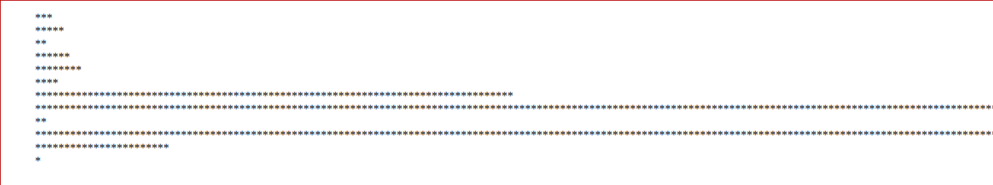

4) Write a Javascript program to validate the Date of Birth entered by the user. It

should be in the form DD-MM-YYYY

<!DOCTYPE html>

<html lang="en">

<head>

<meta charset="UTF-8">

<meta name="viewport" content="width=device-width, initial-scale=1.0">

<title>Q4.DOB_Validator</title>

<script>

function validator(dob) {

var components, day, month, year, num_day, num_month, num_year;

var flag = 1;

try {

if (dob.length == 0)

throw "Empty date";

components = dob.split('-')

if (components.length != 3)

throw "Missing -";

day = components[0];

month = components[1];

year = components[2];

//document.write(components)

if (year.length != 4)

throw "Year length incorrect";

if (month.length != 2)

throw "Month format incorrect";

if (day.length != 2)

throw "Day format incorrect";

num_day = parseInt(day);

num_month = parseInt(month);

num_year = parseInt(year);

//document.write('<br/>' + num_day + ' ' + num_month + ' ' + num_year + '<br/>');

if (isNaN(num_day) || isNaN(num_month) || isNaN(num_year))

throw ('Value not a number/undefined');

if (num_year > 2020) {

throw "Invalid Year"

} else {

if (num_month > 12 || num_month < 1)

throw "Invalid month"

else {

if ((num_month == 2 && (num_day > 29 || num_day < 1)) || (num_month in [1, 3, 5, 7, 8, 10,

12

] && (num_day > 31 || num_day < 1)) || (num_month in [4, 6, 9, 11] && (num_day > 30 ||

num_day < 1)))

throw "Invalid day"

}

}

} catch (error) {

if (error instanceof TypeError)

document.write('Invalid number- cannot be converted to numeric');

else {

document.write('Error : ' + error)

}

flag = 0;

}

if (flag)

document.write('Valid DOB');

}

dob = prompt('Enter DOB in the format DD-MM-YYYY')

validator(dob);

</script>

</head>

<body>

</body>

</html>

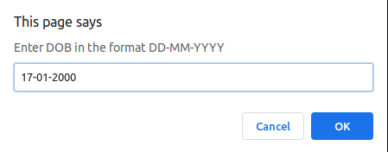



5) Write a JavaScript program which iterates the integers from 1 to 100. For

multiples of three print "Fizz" instead of the number and for the multiples of five

print "Buzz". For numbers which are multiples of both three and five print

"FizzBuzz".

<!DOCTYPE html>

<html lang="en">

<head>

<meta charset="UTF-8">

<meta name="viewport" content="width=device-width, initial-scale=1.0">

<title>Q5.FizzBuzz</title>

</head>

<script>

function fizzbuzz(){

try{

var i=1;

for (i; i<=100; i++){

if(i%3==0 && i%5==0){

document.write('FizzBuzz ');

continue;

}

if (i%3==0){

document.write('Fizz ');

continue;

}

if (i%5==0){

document.write('Buzz ');

continue;

}

document.write(i+' ');

}

}

catch(error){

if(error instanceof TypeError)

document.write('Not a number');

else

document.write('Error : '+error);

}

}

fizzbuzz();

</script>

<body>

</body>

</html>

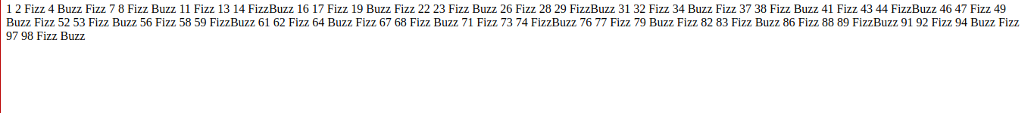

6) Write a function named assignGrade that: • takes 1 argument, a number score. • returns a grade for the score, either "A", "B", "C", "D", or "F". Check the results of your assignGrade function by displaying every value from 60 to 100 5 times .your log should show "For 88, you got a B. For 89, you got a B. For 90, you got an A. For 91, you got an A.", etc., logging each grade point in the range.

<!DOCTYPE html>

<html lang="en">

<head>

<meta charset="UTF-8">

<meta name="viewport" content="width=device-width, initial-scale=1.0">

<title>Q6.Grades</title>

<script>

function assignGrade(num){

try{

val=parseInt(num);

if (val<0 || val>100)

throw "Number not in range";

grade="F";

if (val>=90)

grade="A";

else if (val>=80)

grade="B";

else if (val>=70)

grade="C";

else if (val>=60)

grade="D";

return grade;

}

catch(error){

if (error instanceof TypeError)

document.write('Unparseable input');

else

document.write('Error: '+ error);

}

}

var i=0;

var j;

while (i<5){

for (j=60; j<=100; j++){

g=assignGrade(j);

var article;

if (g =="A" || g=="F")

article='an ';

else

article="a ";

document.write('For '+j+' you got '+ article+g+'<br/>');

}

document.write('<br/><hr><br/>')

i++;

}

</script>

</head>

<body>

</body>

</html>

